

**SOFTWARE REQUIREMENTS SPECIFICATION**

FOR

**AMBULANCE DISTRIBUTION SERVICES**



**Prepared By:**

**Het Patel (180110116037)**

**Devansh Tadhani (180110116053)**

**GCET IT 3rd Year.**

**Table of Contents**

|  |  |  |
| --- | --- | --- |
| **Sr No.** | **Tittle** | **Page No.** |
| **1.** | **Introduction** | 3 |
| **2.** | **General Description** | 4 |
| **3.** | **Functional Requirements** | 5 |
| **4.** | **Interface Requirements** | 5 |
| **5.** | **Non-Functional Requirements** | 5 |
| **6.** | **Design Constrains** | 6 |
| **7.** | **UML Diagrams** | 7-9 |

**1.Introduction:**

**1.1Objective**

As in current pandemic situation, people life count majorly on the medical care. And this can be achieved only if the patient is been at the hospital. Thus, our initiative is to bridge the gap between the ambulance, patient and hospital. By providing a trustable medium in a form of a web application to track the live location of the allocated ambulance and smooth flow even in panic situation as such.

**1.2Users:**

Patient and Driver are the primary users. Apart from them all other are secondary users.

**1.3Features:**

* User Friendly website.
* Map view of hospital/ambulance location.

**1.4Process:**

* User sign up.
* User login.
* User home page.
* User can see the hospital nearby.
* User can generate SOS (Emergency Call).
* User can see the live location of Ambulance allocated.

**2.General Description:**

Given below is general flow of our project.



Fig 2.1 Flow Chart of Project.

**Requirement Analysis:**

**3.Functional Requirements**

* Patient/Driver can login through ID and Password
* New Patient/Driver can Sign up
* Location Access
* Map View
* Ambulance Live location
* Hospitals nearby

**4.Interface Requirements**

For web application the user requires a suitable browser.

Thus, it can be used irrespective of any appliance i.e.

* Mobile phone
* PC
* Laptops
* Tablets etc.

**5.Non-Functional Requirements**

* Location service provided by Google API.
* The system can handle multiple transaction at a same time.
* The system should support almost all browsers.

**6.Design Constrains**

Website supports:

For the frontend framework:

* HTML
* CSS
* Bootstraps

For the backend framework:

* PHP (server side)
* JavaScript/jQuery (client side)

For the Database Management:

* MySQL

For Location Management:

* Google Location API

**7. UML Diagrams**

7.1 Activity Diagram

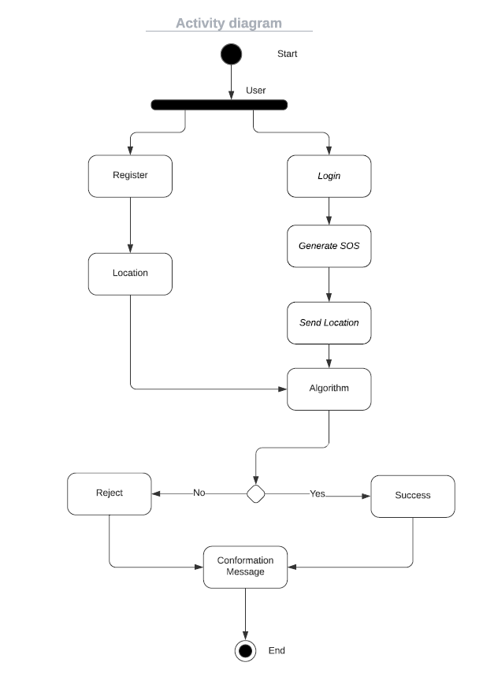

7.2 Use Case Diagram

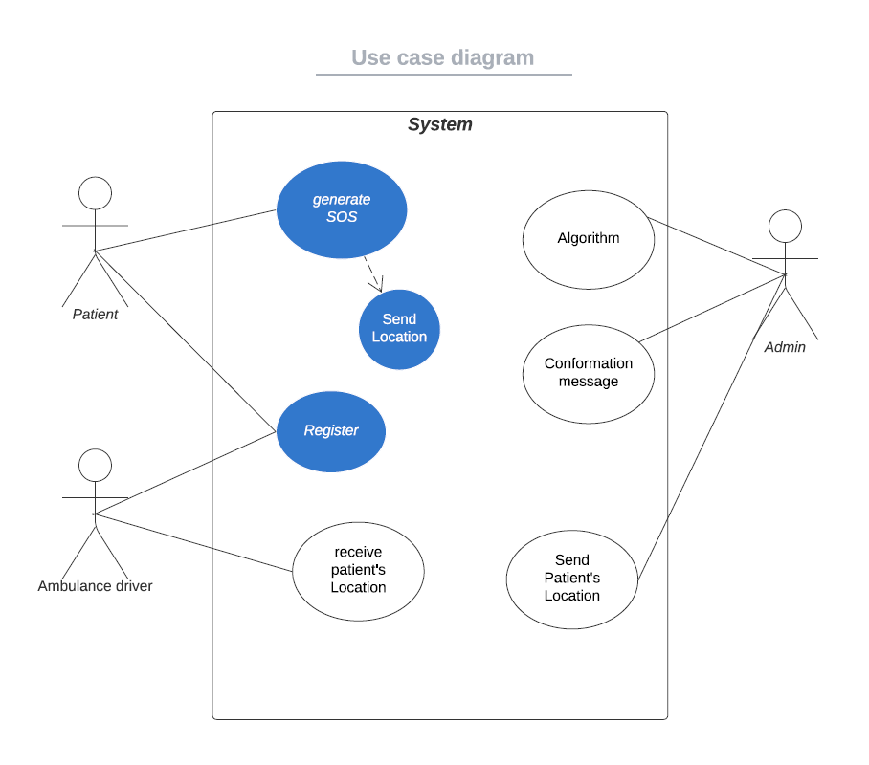

7.3 Class Diagram

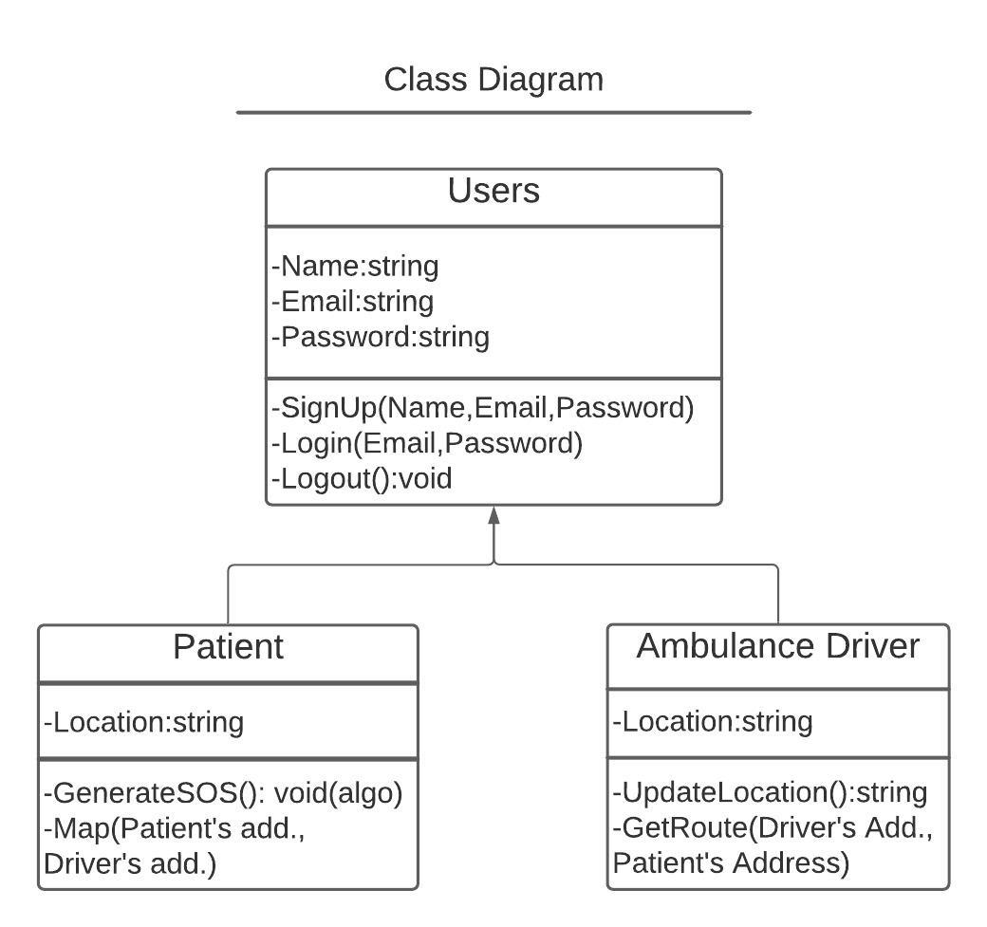

7.4 Sequence Diagram

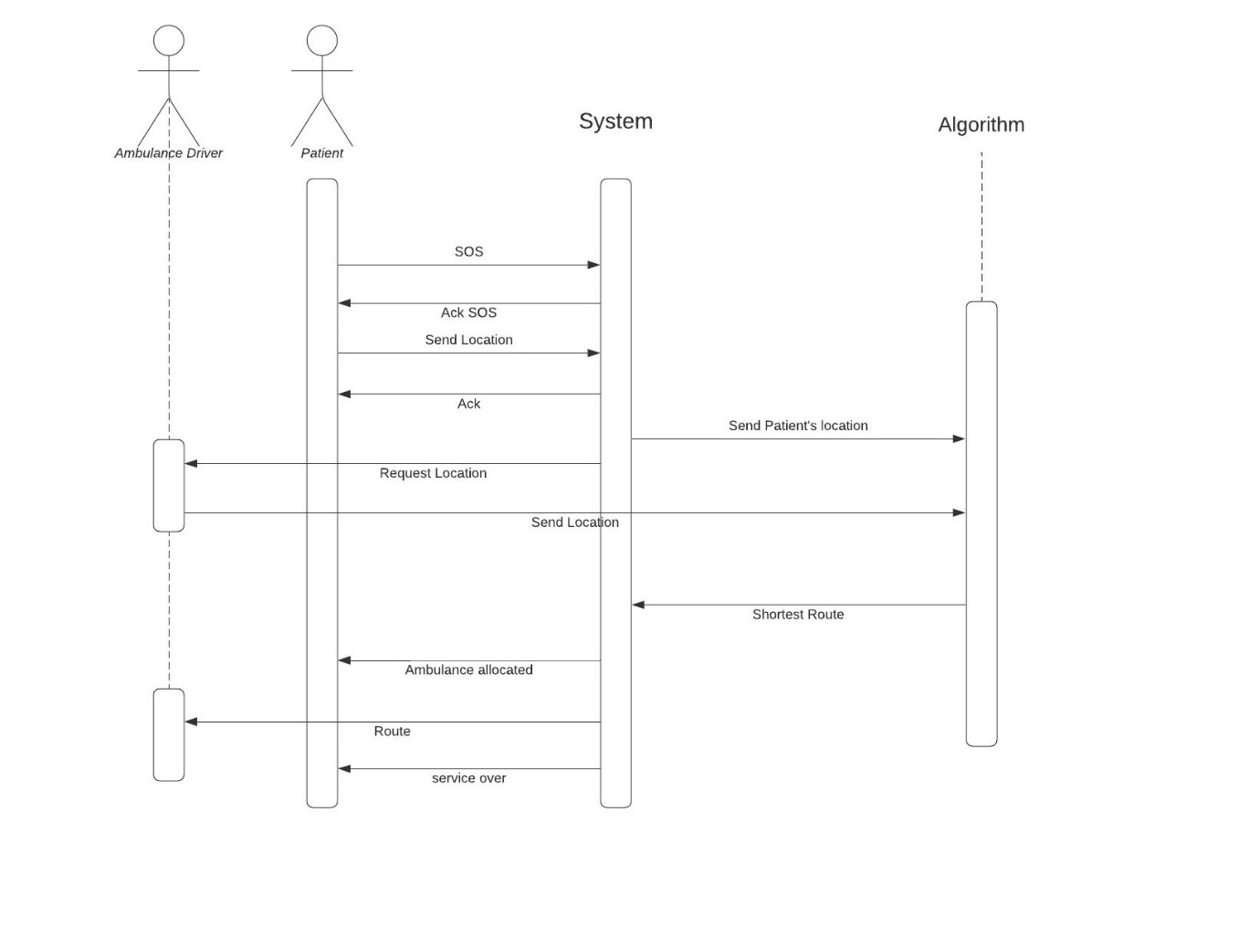

7.5 Component Diagram

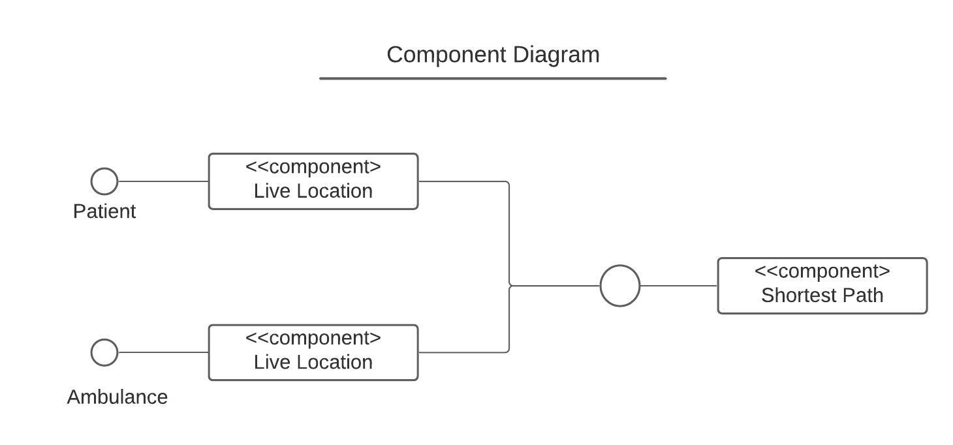

7.6 State Diagram

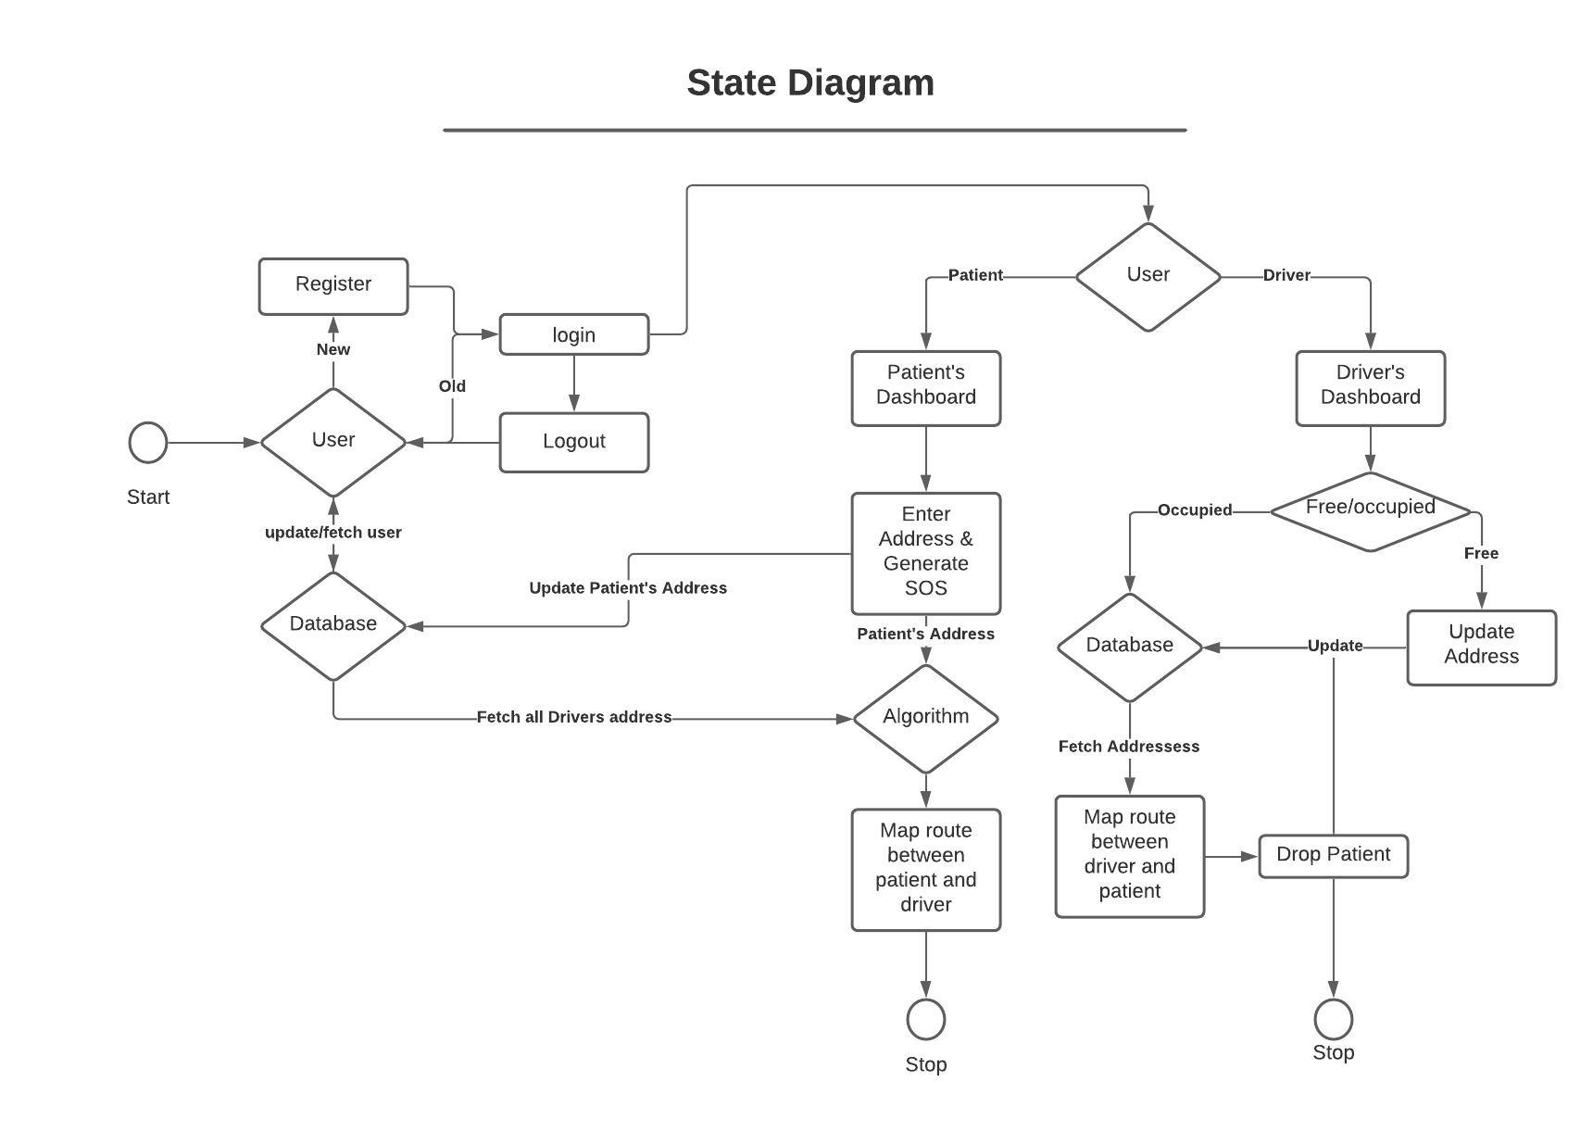

7.7 Data Flow Diagram

